**Experiment 6:**

**Aim: ALP to sort numbers in ascending/descending order.**

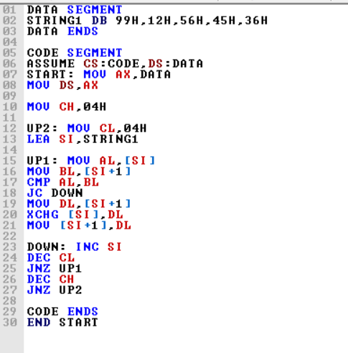**Ascending Order:**

**Code:**

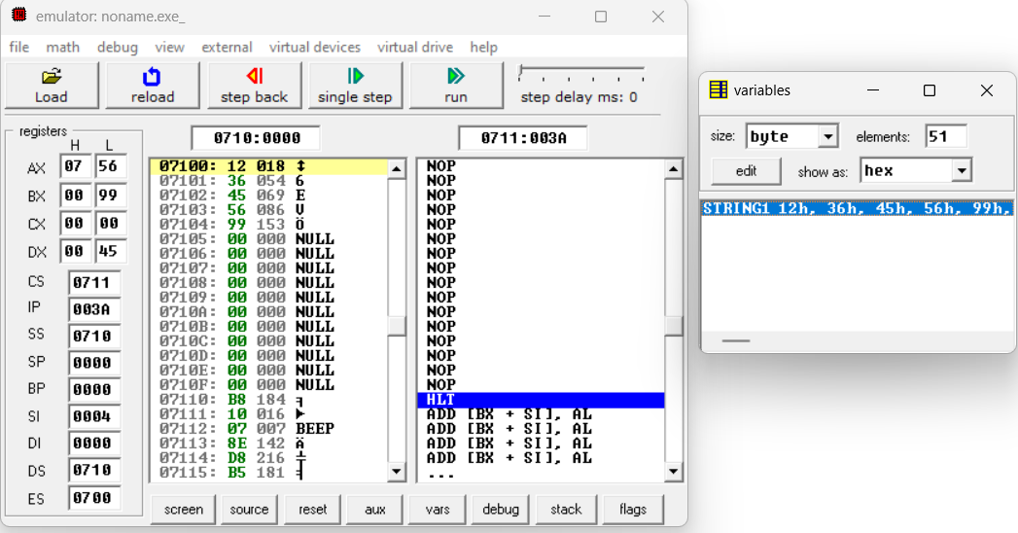**Output:**

**Descending Order:**

**Code:**

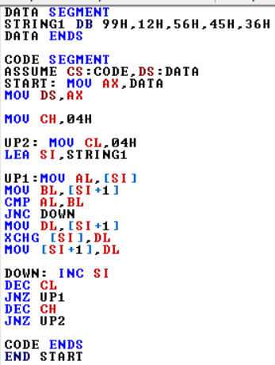

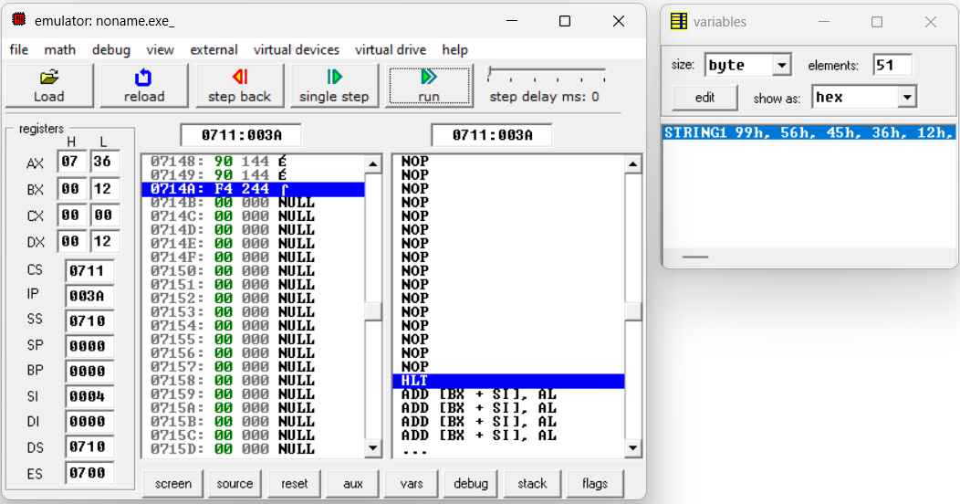**Output:**